EECS 498-007 Deep Learning for Computer Vision

Contents

Lecture 1 – Introduction 3

Lecture 2 – Image Classification 4

Challenges 4

Data-driven approach 4

*Collect a dataset of images and labels* 5

*Use machine learning to train a classifier – E.g. Nearest Neighbour Classifier* 6

Lecture 3 – Linear Classifiers 9

The Algebraic Viewpoint 9

The Visual Viewpoint 10

The Geometric Viewpoint 10

Loss Functions 11

Cross-Entropy Loss 11

Multiclass Support Vector Machine (SVM) Loss 12

Regularisation 13

Motivation 13

Implementation 13

Lecture 4 – Optimisation 15

Numeric Gradient 15

Analytic Gradient 16

Gradient Descent 16

Batch Gradient Descent (or Full Batch Gradient Descent) 16

Minibatch Gradient Descent / Stochastic Gradient Descent 16

Second Order Optimisation 20

Lecture 5 – Neural Networks 21

Feature Transforms 21

Image Features: Color Histogram 22

Image Features: Histogram of Oriented Gradients (HoG) 22

Image Features: Bag of Visual Words (Data-Driven!) 23

Image Features: Continued 23

Neural Networks 24

Activation Functions 25

Universal Approximation Theory 26

Convex Functions 26

Lecture 6 – Back Propagation 27

Derive gradients on paper 27

Computational Graphs 27

Patterns in Gradient Flow 29

Backprop Implementation: “Flat” gradient code 29

Backprop Implementation: Modular API 29

Vector and Tensor Backpropagation 31

Vector Backpropagation 31

Tensor Backpropagation 32

Automatic Differentiation 33

Higher-order Derivatives 33

# Lecture 1 – Introduction

Computer vision: building artificial systems that process, perceive, and reason about vision data.

Learning: building artificial systems that learn from data and experience.

Deep Learning: hierarchical learning algorithms with many “layers”, (very) loosely inspired by the brain.

AI: a set of technologies that allow computers to perform tasks that typically required human intelligence.

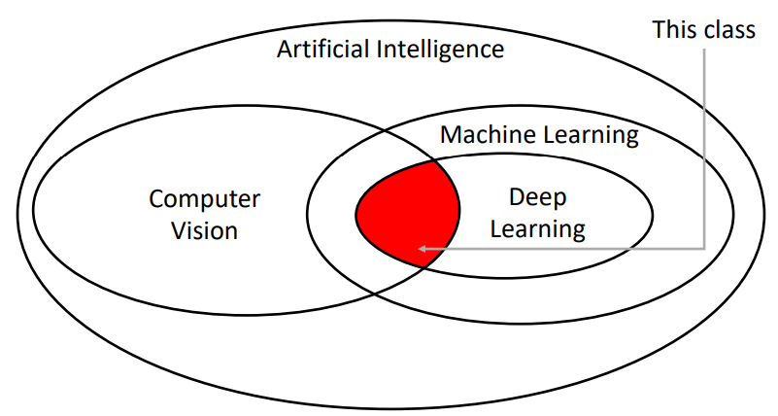Not all AI is based on machine learning, “symbolic AI” or “Good Old-Fashioned AI (GOFAI)” mainly relies on explicitly programmed rules and logic to behave like a human.

# Lecture 2 – Image Classification

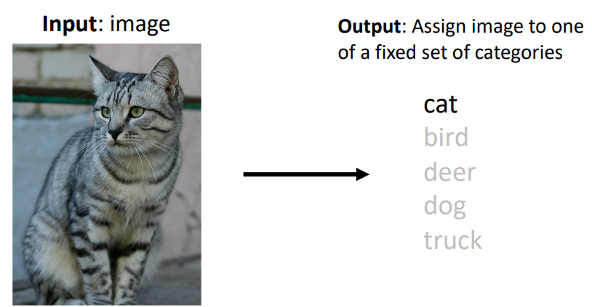Image classification is a core computer vision task, where the goal is to assign a label from a fixed set of categories to an input image. An RGB colour input image is simply some 3D array of red, green, and blue intensity values.

## Challenges

Whilst image classification is relatively trivial for people, there are many challenges involved with developing an image classification algorithm, including but not limited to:

* Viewpoint variation: Even a slight shift in the camera’s position will change all the pixel values in the image.
* Fine-grained categories: e.g. There are many different breeds of cats with different appearances.
* Intraclass variation: e.g. cats of the same breed still look different to one another due to their unique markings.
* Background clutter: Objects may blend into their background, making them hard to identify.
* Illumination conditions: The exact same scene with different lighting conditions produces a completely different image array.
* Deformation: Many objects are not rigid bodies and can be deformed in extreme ways.
* Occlusion: Sometimes only a portion of the object is visible.
* Scale variation: Objects exist as different sizes both in the real-world and in terms of their extent in the image.

## Data-driven approach

Whilst it may technically be possible to write an algorithm that encodes some of the techniques humans use to identify cats for example (e.g. extract edges, then search edges for pointy ears, whiskers, etc.), this approach is brittle and not easily adapted to classify different classes of images. Instead, we can use a **data-driven approach**, where we:

1. Collect a dataset of images and labels
2. Use machine learning to train a classifier
3. Evaluate the classifier on new images

### *Collect a dataset of images and labels*

Some commonly used image classification datasets include:

* 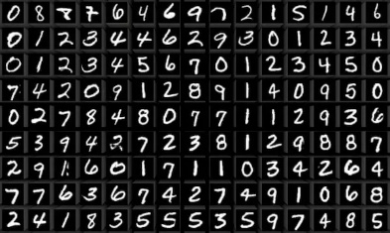MNIST – a dataset of handwritten digits
  + Classes: 10, digits 0 to 9
  + Image size: 28x28 grayscale
  + Num. training: 50k
  + Num. test: 10k
  + Sometimes called the “drosophila (fruit fly) of computer vision” due to it being a simple baseline. **Results from MNIST often do not hold for more complex datasets.**
* 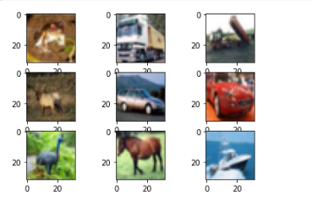CIFAR10
  + Classes: 10, e.g. airplane, automobile, cat, deer, dog
  + Image size: 32x32 RGB
  + Num. training: 50k
  + Num. test: 10k
* CIFAR100
  + 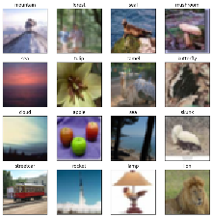Classes: 100, with 20 “superclasses” e.g. aquatic mammals, trees, etc.
  + Image size: 32x32 RGB
  + Num. training: 50k
  + Num. test: 10k
* 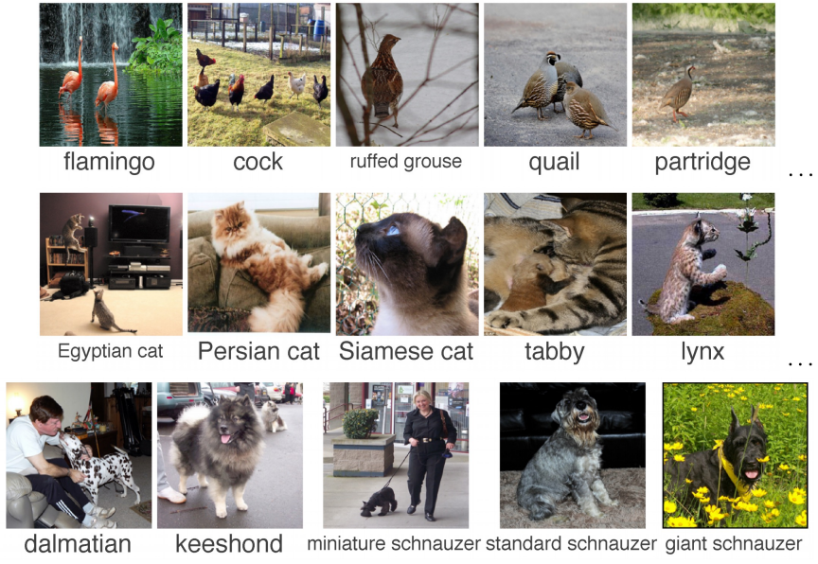ImageNet
  + Classes: 1000
  + Image size: Variable, often resized to 256x256 for training
  + Num. training: ~1.3M
  + Num. validation: 50k
  + Num. test: 100k
  + Due to the large number of classes, the **Top 5 accuracy** is often used as the performance metric, where the algorithm predicts 5 labels for each image and one of them needs to be right
  + Often still used as the standard for benchmarking a classification model, however, it can be expensive to train on.
* 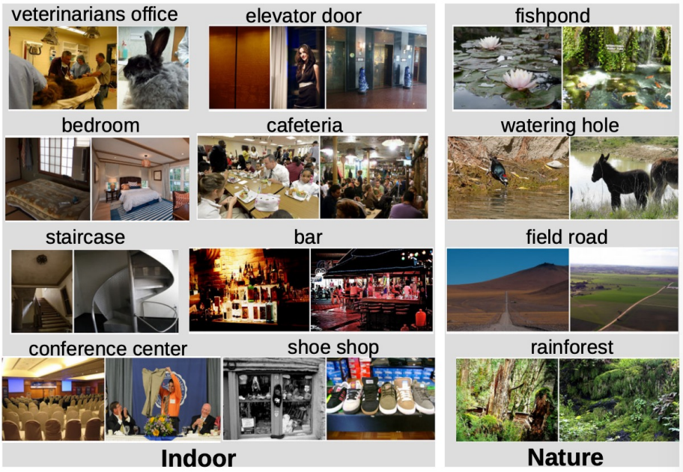MIT Places
  + Classes: 365, scenes like “bedroom”, “bar”, “rainforest”
  + Image size: Variable, often resized to 256x256 for training
  + Num. training: ~8M
  + Num. validation: 18.25k
  + Num. test: 328.5k
  + Like ImageNet but with scenes rather than objects
* Omniglot
  + Classes: 1623, characters from 50 different alphabets
  + Image size: 105x105
  + Num.: **Only 20 images per category**
  + Used to test few-shot learning

### *Use machine learning to train a classifier – E.g. Nearest Neighbour Classifier*

The Nearest Neighbour Classifier simply takes a test image and compares it to every single one of the training images, and returns the label of the closest training image. This makes training very quick (O(1) for simply copying pointers) and testing very slow (O(n) to compare against every image in the training set). This is **bad**.

There are many methods for fast / approximate nearest neighbours, [example](https://github.com/facebookresearch/faiss).

We can use different distance formulas to compare two different images, to provide different results. For example, the L1 distance is:

$$d_{1}\left(I_{1},I_{2}\right)=\sum_{p}{\left|I_{1}^{p}-I_{2}^{p}\right|}$$

Where the sum is taken over all of the pixels $p$.

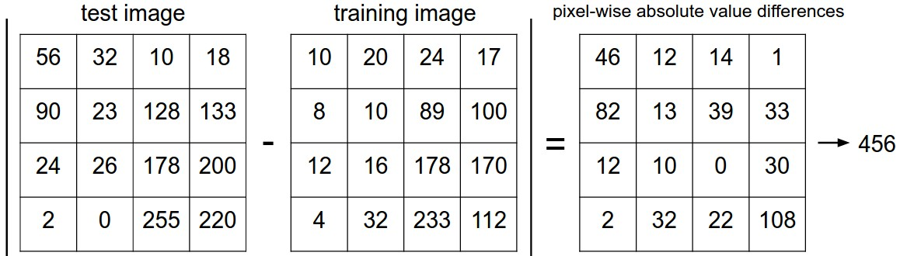Visually, the L1 distance procedure is:

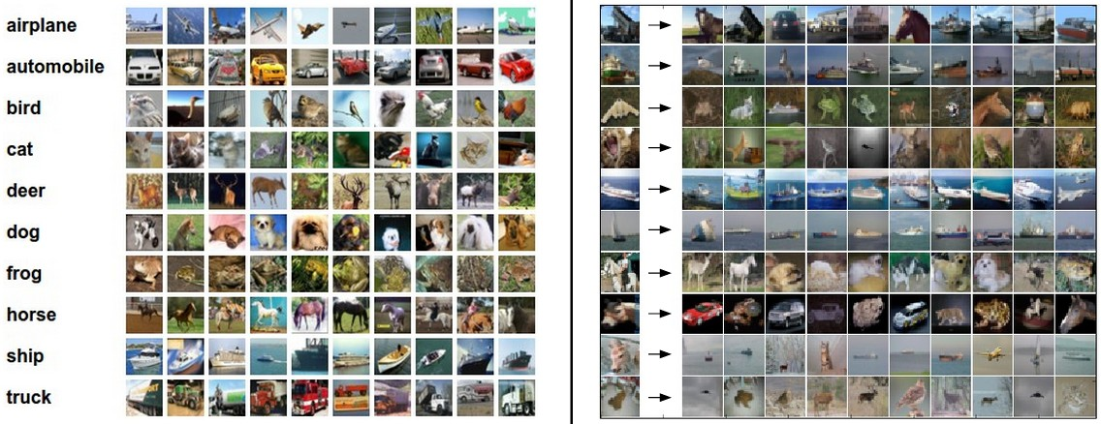An example is given below for test images in the left-hand column, the top 10 nearest neighbours are returned. Notice that while the nearest neighbours are visually similar, they’re not the correct class most of the time.

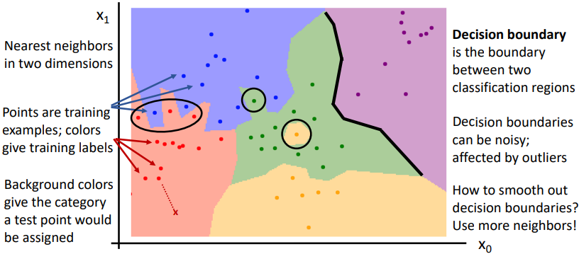If you plot the regions which are closest to the training examples and then colour them according to their training label, you can visualize the **decision boundaries**.

Instead of finding the nearest single neighbour, you can take a majority vote from the K closest points. For example, K=3 means you find the closest 3 images in the training set to the test image and then take the majority vote to classify the test image. This is referred to generally as **k Nearest Neighbour** (**kNN**). Using more neighbours helps to smooth decision boundaries and reduces the effect of outliers.

The **L2 (Euclidean) distance** is another choice for the distance calculation:

$$d_{2}\left(I_{1},I_{2}\right)=\sqrt{{\sum_{p}{\left(I_{1}^{p}-I_{2}^{p}\right)}}^{2}}$$

#### Hyperparameters – What is the best K value, what distance metric do I use?

Selecting a K value and the distance metric for the Nearest Neighbour Classifier Hyperparameters are very problem dependent. Outlined below is the common train-validation-test method for choosing hyperparameters and then evaluating the model:

1. The model is trained on the training set
2. Its performance is tested on the validation set
3. Steps 1 and 2 are repeated with differing hyperparameters
4. The model that performs the best on the validation set is then tested on the test set. No changes should be made based on the performance on the test set (to avoid contamination of the data).

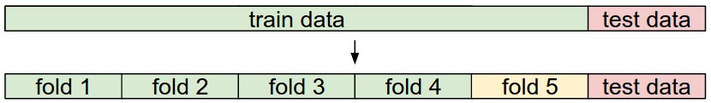**K-fold cross validation** extends this idea by first separating the test set, and then splitting the remaining data into training and validation sets in k different ways. The steps are then the same as before, except the model’s performance is the average of its performance on each validation fold.

#### The Problem with the Nearest Neighbour Classifier

As the number of training samples goes to infinity, the Nearest Neighbour Classifier can represent any continuous function! (If the number of training samples was infinite, any test sample would also be in the training set). *However, the number of training samples that you need for a dense coverage of the sample space increase exponentially with dimension*. For example, the number of possible 32x32 binary images is:

$$2^{32×32}≈{10}^{308}$$

Clearly, having enough training samples to give good results for even very small binary images is impossible.

Therefore, Nearest Neighbour Classifiers are seldom used on raw pixels. **They do however work well on ConvNet features**.

# Lecture 3 – Linear Classifiers

Many machine learning models take a parametric approach to classifying images by defining some function $f$ that takes in the **image $x$** and a matrix of **parameters $W$** to output a vector of **scores** that represent the classifier’s prediction for each class. Arguably the most simple function, as used in a **linear classifier**, is a linear mapping:

$$f\left(x_{i},W,b\right)=Wx_{i}+b$$

Where, using the CIFAR10 dataset with 32x32x3 sized images as an example:

* $f\left(x_{i},W,b\right)$ outputs a vector equal in size to the number of classes $\left(10,1\right)$
* The weights matrix $W$ therefore, has size $\left(10, 32×32×3\right)=\left(10, 3072\right)$
* And the **bias** vector has size $\left(10,1\right)$

There are three common different viewpoints we can use to view the linear classifier:

* The algebraic viewpoint
* The visual viewpoint
* And the geometric viewpoint

## The Algebraic Viewpoint

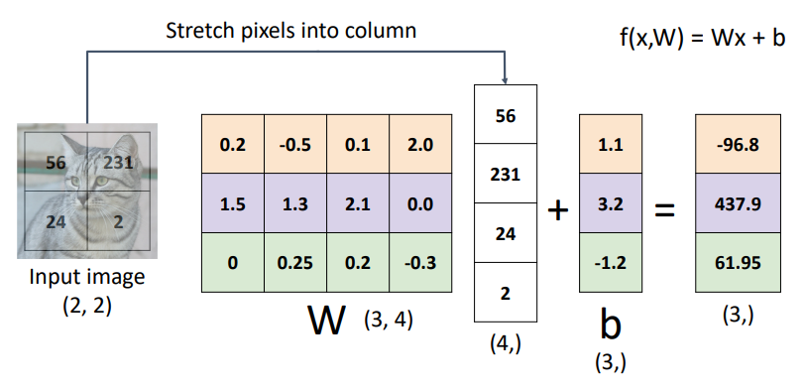Using a simple $2×2$ grayscale image to be classified as one of three classes as an example. The weights matrix $W$ has size $\left(3, 4\right)$ and the bias vector has size $\left(3, 1\right)$. We can see below that each row of $W$ and $b$ are effectively their own classifier in parallel, one for each class.

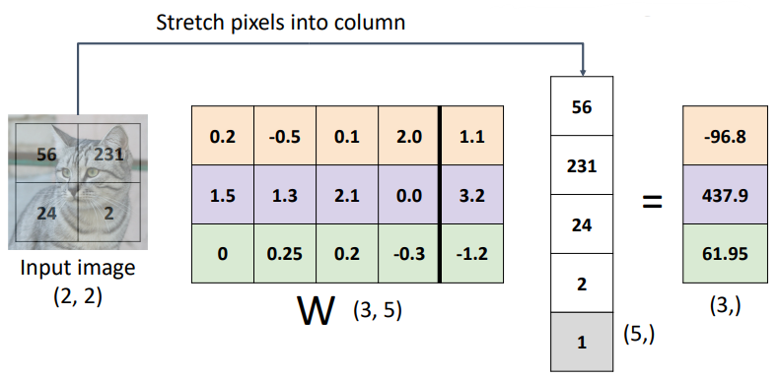Note: a common trick known as the **bias trick** can be used to combine the bias terms into the weights matrix as an additional column, as long as the input vectors are appended with a $1$, as shown below:

## The Visual Viewpoint

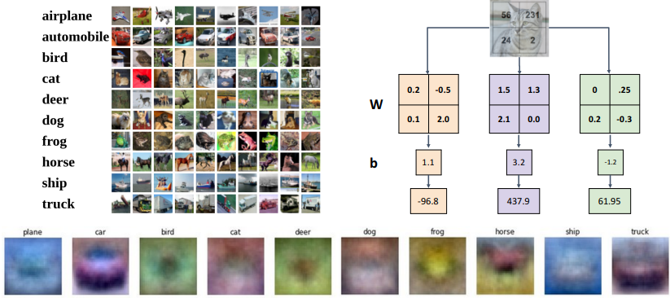Instead of stretching the pixels of the image into a column, we can imagine reshaping each row of the weights matrix $W$ into an image! After training the linear classifier, each of these rows is essentially a learned “template” to be used for matching against its corresponding class. You can actually plot each row of the weights matrix $W$ as an image to visualize what the learned “templates” look like, as seen at the bottom of the image below.

In this way, a linear classifier can be thought of in a similar manner to a kNN Classifier, except the test image is compared to only a single “template” learned from the dataset instead of every dataset image directly, and the negative of the inner product is used as the distance instead of the L1 or L2 distance.

## The Geometric Viewpoint

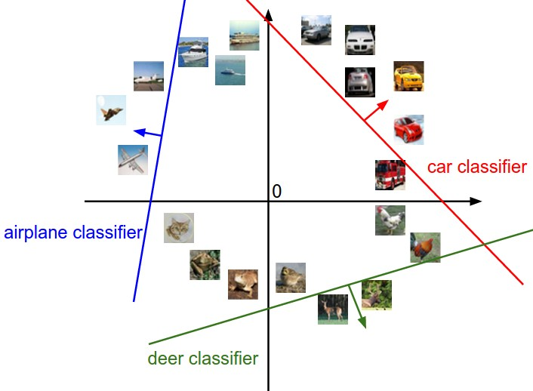Since CIFAR10 images are represented by 3072 values, we can image each image in our dataset as a point in a 3072-dimensional space. Each class score of a linear classifier is then a linear function over this space, providing some score for each possible 3072-dimensional image.

The above is an imagining of this 3072-dimensional space as a 2D plot. The red line shows all of the points in the plot which get a score of zero for the car class, whilst the red arrow shows the direction of increase, so all points to the right have linearly increasing scores.

As we saw above, every row of $W$  is a classifier for its corresponding class. The geometric interpretation of these rows is that as we change them, the corresponding line in the pixel space will rotate. The biases $b$ , on the other hand, allow our classifiers to translate the lines. In particular, if we do not include any bias terms, plugging in $x_{i}=0$  would always give a score of zero regardless of the weights, so all lines would be forced to cross the origin.

## Loss Functions

So far, we have described the weights matrix $W$ and the bias vector $b$, but how do we quantify how good our $W$ and $b$ are for our classification task? A loss function (also called an objective function or cost function) tells us how good our current classifier is. A high loss indicates poor performance.

For a single sample in our dataset $\left(x_{i}, y_{i}\right)$ where $x_{i}$ is the image and $y_{i}$ is the known label, the loss is some function $L_{i}$:

$$L_{i}\left(f\left(x_{i},W\right),y_{i}\right)$$

And the loss for the dataset is the average of the per-example losses:

$$L=\frac{1}{N}\sum_{i}{L_{i}\left(f\left(x_{i},W\right),y_{i}\right)}$$

### Cross-Entropy Loss

Cross-entropy (CE) loss is used in multinomial (multiple classes) logistic (i.e. classification) regression when we want to interpret raw classifier scores as probabilities. We use the **softmax** function to take our output score vector of arbitrary real-valued numbers and transform them to an output vector of values between 0 and 1 that sum to 1. These output values can be interpreted as probabilities, representing the classifier’s confidence in each class being the correct classification.

For the output scores of a linear classifier $s=f\left( x_{i},W\right)$, softmax $P$ for class $k$ is defined as:

$$P\left(Y=k | X=x_{i}\right)=\frac{\exp{s_{k}}}{\sum_{j}{\exp{s_{j}}}}$$

The **cross-entropy loss** is then defined as the negative log of the softmax’s output for the correct class, i.e;

$$L_{i}=-\log{P\left(Y=y_{i} | X=x_{i}\right)}$$

* What is the minimum and maximum possible loss $L_{i}$?
  + Minimum: $0$ when $P\left(Y=y_{i} | X=x_{i}\right)=1$
  + Maximum $∞$ as $P\left(Y=y_{i} | X=x_{i}\right)→0$
* If all scores are small random values upon initialization, what loss can we expect?
  + We expect the softmax output probabilities to be approximately equal. Therefore, for $C$ number of classes:
 $$L_{i}=-\log{P\left(Y=y_{i} | X=x_{i}\right)}=-\log{\frac{1}{C}}=\log{C}$$

 + For 10 classes in the CIFAR10 dataset, we can expect the initial CE loss to be $L_{i}=\log{10}≈2.3$

### Multiclass Support Vector Machine (SVM) Loss

SVM loss “wants” the correct class for each image to have a score higher than the incorrect classes by some fixed margin $Δ$. The multiclass SVM loss for the $i$-th image in the dataset is defined as:

$$L_{i}=\sum_{j≠y_{i}}{\max\left(0, s_{j}-s_{y_{i}}+Δ\right)}$$

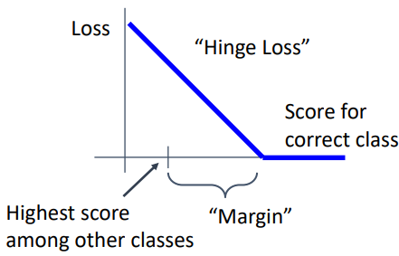This type of loss function is also referred to as **hinge loss** and can be visualized as:

* What is the minimum and maximum possible loss $L_{i}$?
  + Minimum: $0$ when $s_{j}-s_{y_{i}}>Δ$
  + Maximum $∞$
* If all scores are small random values upon initialization, what loss can we expect?
  + We expect the scores to also be random, so the differences between them should be approximately zero. Therefore, for $C$ number of classes, we sum $C-1$ lots of $Δ$:

$$L_{i}=\left(C-1\right)Δ$$

## Regularisation

### Motivation

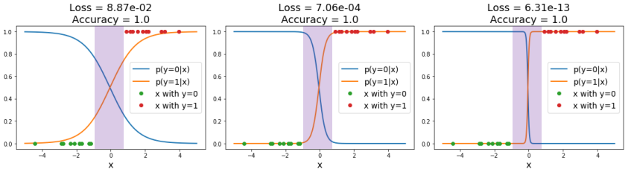Loss functions encourage good performance on *training data* but ultimately, we really care about *test data*. We say a model is **overfit** when it performs too well on the training data and has poor performance on unseen data. For example, the below three plots show the same training data in green and red, and the models’ predicted scores for the two classes in orange and blue respectively. The rightmost model has the lowest loss, but it is way too confident in the purple region with no training data, which can lead to poor generalisation on unseen data.

Additionally, if using SVM loss it is possible to have many different weights matrices $W$ and bias vectors $b$ which give the exact same loss. How do we differentiate between these models?

### Implementation

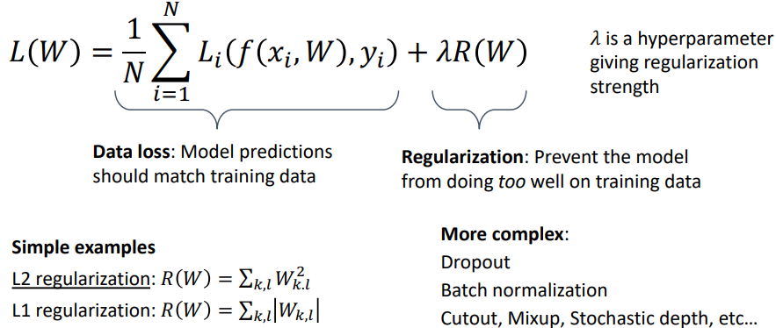We can add an additional term to our loss function to express preferences about the weights $W$ and to prevent our model from doing *too* well on the training data:

#### Expressing Preferences

Regularisation allows us to penalise model behaviours that we consider undesirable. For example:

* If we have the input $x=\left[1, 1, 1, 1\right]$
* and two different weights matrices $w_{1}=\left[1, 0, 0, 0\right]$ and $w_{2}=\left[0.25, 0.25, 0.25, 0.25\right]$
* both models give the same prediction: $w_{1}^{T}x=w_{2}^{T}x=1$, so data loss will always be the same.
* However, model 1 only uses the first input dimension and completely disregards the other dimensions.
* If we use L2 regularisation, which sums the square of each weight and adds this to the loss while training, we can encourage the weights to be smaller and more spread out.

#### Preventing overfitting

Penalising large weights also tends to improve generalisation, as no input dimension can have a disproportionately large influence on the scores.

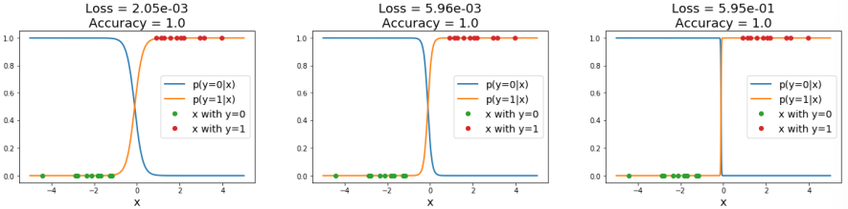For example, using L2 regularisation on the previous classification example causes loss to actually *increase* for the overfit model.

Note that biases do not have the same effect since, unlike the weights, they do not control the strength of influence of an input dimension. Therefore, it is common to only regularize the weights $W$  but not the biases $b$ . However, in practice this often turns out to have a negligible effect.

# Lecture 4 – Optimisation

Very generally, the process of optimisation usually refers to finding the weights $W$ that minimize the loss function $L$, i.e. the optimal weights $W^{*}$ are:

$$W^{*}=\arg{\min_{W}{L\left(W\right)}}$$

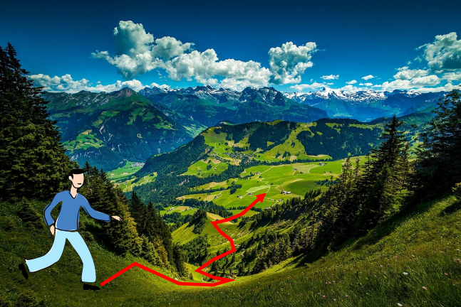And a common way to visualize the search for these optimal weights is traversing a high dimensional landscape to find the lowest valley. We are doing this with no sight, i.e. no way to determine $W^{*}$ from afar, but we can feel around our local position for information.

By feeling around our local position, we can determine the direction of steepest decent and then traverse down that direction and then repeat for each step we take. Functionally this is equivalent to calculating the derivative of the loss function with respect to the weights $\frac{dL}{dW}$, and then moving in the negative direction of the gradient.

## Numeric Gradient

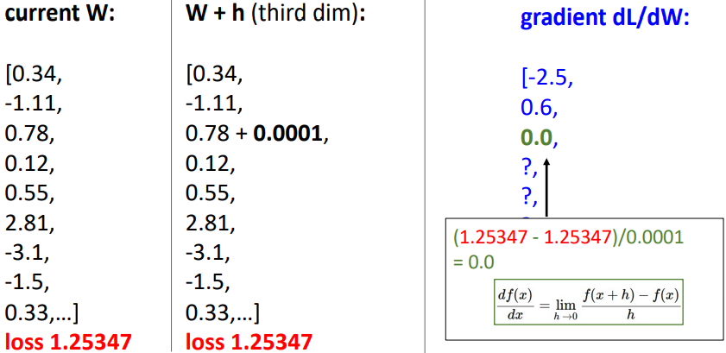A naïve approach to calculating $\frac{dL}{dW}$ is to perturb each element in $W$ by a small amount and then determine the change in loss, then use rise-over-run to approximate the derivate for that element of $W$, repeating for all elements in $W$. This approach is **slow** (O(n-dimensions)) and **approximate**.

## Analytic Gradient

Alternatively, we can use calculus to actually compute the analytic gradient based on the model and the formula of our selected loss function and regularisation technique. This method is **exact**, **fast**, but can be **error-prone** due to needing to calculate the derivatives analytically.

In practice, we should always use analytic gradient, but we should check our implementation using the numerical gradient. This is called a **gradient check**.

## Gradient Descent

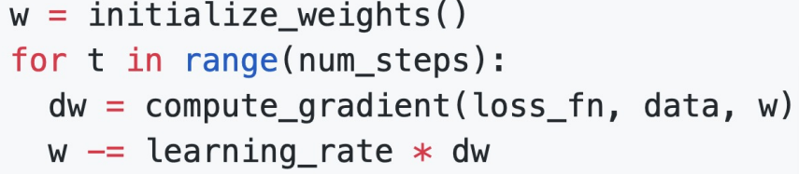The method described above of “feeling around our local position” and then iteratively stepping in the direction of steepest descent (i.e. the negative gradient) is known as **gradient descent**. The basic vanilla function looks like:

Where the weight initialisation method, number of steps, and learning rate are all hyperparameters.

### Batch Gradient Descent (or Full Batch Gradient Descent)

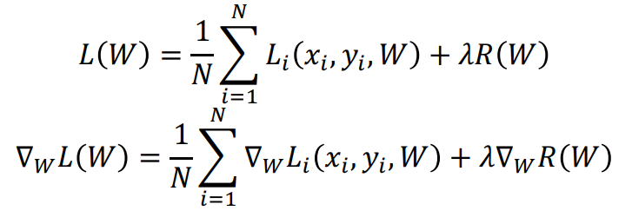Recall that our loss at each step is the average of the loss of the model on the entire training set. Then the gradient of the loss with respect to the weights is the average of the gradients on the entire training set. That is:

This can be very expensive and impractical when the training set is very large. Do we need to calculate the gradient on every single training data point?

### Minibatch Gradient Descent / Stochastic Gradient Descent

Stochastic Gradient Descent approximates the gradient at each step by using a **minibatch** of examples, commonly 32, 64, 128, or 256 (technically SGD only refers to the case where the minibatch is a single example, however people now commonly use it to refer to minibatch 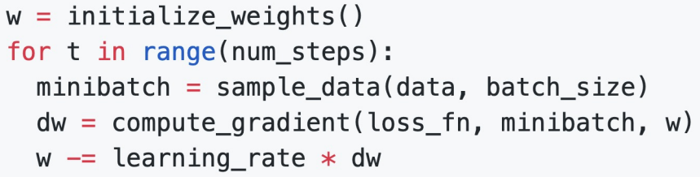gradient descent). The basic function looks like:

Where the batch size and sampling method are additional hyperparameters.

Training is generally not super sensitive to batch size, and in practice you generally make the batch size as big as you can fit on the GPU(s).

There are some problems with the above implementation of SGD however:

* If the loss changes quickly in one dimension and slowly in another, there is unlikely to be an optimum step size which doesn’t cause very slow progress along the shallow dimension and oscillations along the steep direction. Note: this is usually indicated by a high **condition number**, the ratio of largest to smallest singular value of the Hessian matrix.
* The SGD algorithm can get stuck at points where the gradient is zero, at:
  + Local minimums, where the loss function curve curves upwards in all directions. These are rare in very high dimensional space.
  + Saddle points, where the loss function curve curves upwards in some directions and downwards in others. Much more common in very high dimensional space.
* The gradients are approximations from minibatches so they can be noisy

#### Stochastic Gradient Descent + Momentum

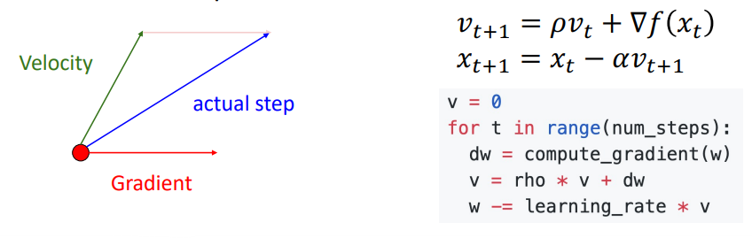Momentum is the idea of “building up a velocity” as the running mean of previous gradients. The step used to update the weights then comes by combining the gradient at the current step with the velocity. This gives similar behaviour to a marble rolling down a hill. The velocity is usually reduced by some “friction” value $ρ$ (typically 0.9 or 0.99). The formula for SGD+Momentum is:

SGD+Momentum addresses some of the problems with SGD outlined above:

* The velocity acts to smooth out oscillations by acting as a moving average.
* The velocity helps to carry the weights over local minima and saddle points, thanks to the momentum.
* The velocity acts to smooth out the gradient noise that comes from using minibatches.

#### Nesterov Momentum

Nesterov momentum uses a slightly different method to calculate the “actual step” from the gradient at the current point, and the velocity. The gradient is computed at the point where updating using only the velocity would take us, and it is then mixed with the velocity to give the actual update direction.

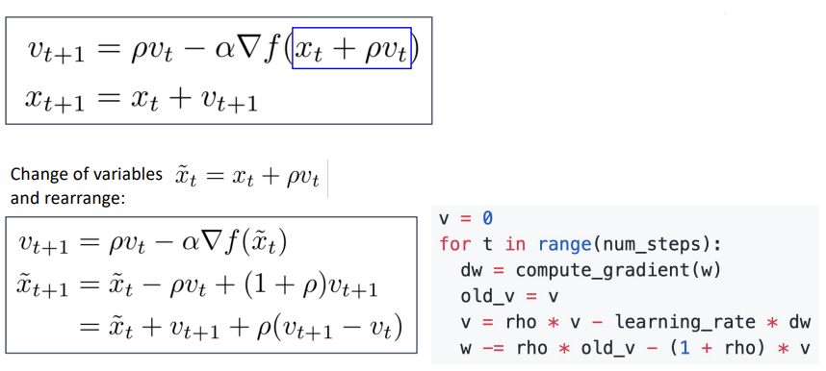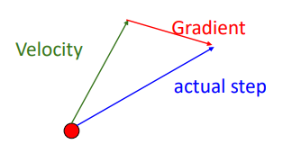

#### AdaGrad

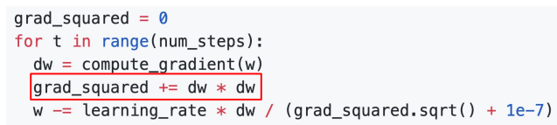AdaGrad is not a momentum-based optimisation algorithm like SGD+Momentum and Nesterov Momentum. Rather than tracking the historical sum of gradient values, we keep track of the historical sum of squared gradient values. Then, when updating our weights matrix, we divide the current gradient by the square root of the historical squared gradient values. This effectively gives an adaptive learning rate (AdaGrad = adaptive gradient):

This technique addresses the problem of having large gradients in one direction and small gradients in another direction. Large gradients divide through to cause small step sizes, and small gradients divide through to cause large step sizes. Progress along “steep” directions is damped, progress along “flat” directions is accelerated.

As the historical sum of squared gradients keeps accumulating (due to the squared gradients always being positive), learning can slow dramatically over time as you divide the step by larger and larger numbers.

#### RMSProp: “Leaky AdaGrad”

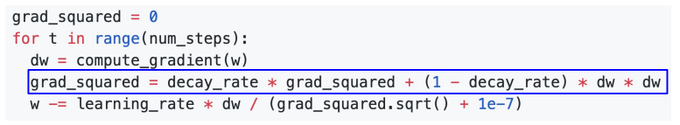To fix the problem of AdaGrad halting over time due to the squared gradients becoming too large, RMSProp (AKA. Leaky AdaGrad) adds a decay rate term to not accumulate squared gradients so fast.

#### Adam): RMSProp + Momentum + bias correction

Adam (adaptive moment estimation) is a very common optimisation algorithm that effectively combines the idea of momentum and adaptive learning rate from AdaGrad/RMSProp. In statistics, the first moment of a distribution is simply the mean, and the second moment is the variance.

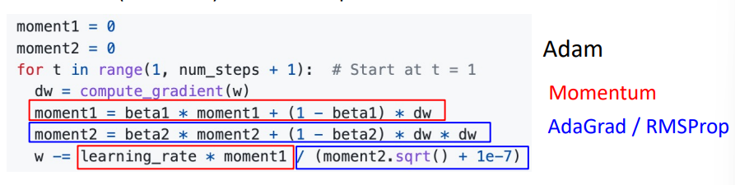Combing RMSProp and Momentum gives:

Where:

* The first moment​ is the running average of the gradients. It smooths out the fluctuations in the gradient and captures the general direction in which the gradient is pointing over time.
* The second moment is the running average of the squared gradients. This moment captures how large or small the gradients are over time, helping the optimizer adjust the step size (learning rate) based on how "volatile" the gradients are.

The above form has the problem that the first and second moment estimates start at zero and $β_{1}$ and $β_{2}$ are generally $≈0.999$, so the very first step size can be very large (if the second moment is near zero after the first update, you divide by the square root of near zero, taking a very large step). Essentially, the estimates for the first and second moments are biased towards zero at the start of training.

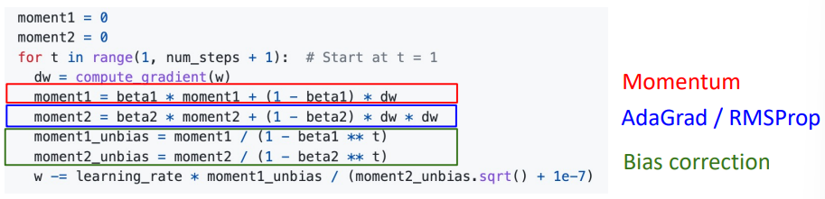A **bias correction** is used to counter this. Giving the full form of:

#### AdamW: Decoupled Weight Decay

Recalling L2 regularisation from the previous lecture, in practice instead of adding a $λ{\left|W\right|}^{2}$ term to the loss function, it is much more common to add a $2λW$ term to the gradient. The term **weight decay** refers to adding a $ηλW$ term (where $η$ is the learning rate) to the update step instead. In some optimisers, L2 regularisation and weight decay are equivalent (SGD, SGD+Momentum), so weight decay is often implemented by adding L2 regularisation. However, **L2 regularisation and weight decay** **are not the same for adaptive methods** (AdaGrad, RMSProp, Adam, etc.).

AdamW is the Adam optimiser with the weight decay term “decoupled”, i.e. added to the update step instead of to the gradients. **“AdamW should probably be your *default* optimiser for new problems”** – Justin Johnson. SGD+Momentum can outperform Adam but may require more tuning.

#### Comparison of Optimisation Algorithms

### Second Order Optimisation

The above optimisation algorithms are all first order algorithms, they only use the first derivation to approximate the loss surface (e.g. a line in 2D space, hyperplane in high dimensional space). Second order optimisers use the gradient and the Hessian matrix (the matrix of second order partial derivatives) to approximate the loss function surface. This takes into account the loss’ curvature, taking bigger steps in regions of low curvature.

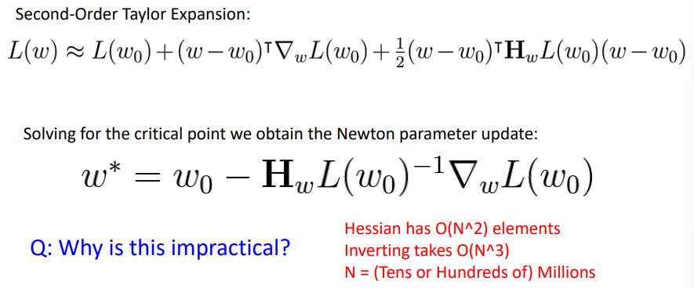Second order Newtonian algorithms require inverting the Hessian matrix which is very expensive.

In practice, approximate methods such as BFGS are used instead (calculates the approximate inverse Hessian with rank 1 updates over time, $O\left(n^{2}\right)$ each). **L-BFGS**, limited memory BFGS, does not form/store the full inverse Hessian.

L-BFGS works very well in full batch, deterministic mode. i.e. if you have a single, deterministic $f\left(x\right)$ then L-BFGS will probably work very nicely. However, it does not transfer very well to mini-batch setting. Adapting second-order methods to large-scale, stochastic setting is an active area of research. If you can afford to do full batch updates then try out L-BFGS (and don’t forget to disable all sources of noise)

# Lecture 5 – Neural Networks

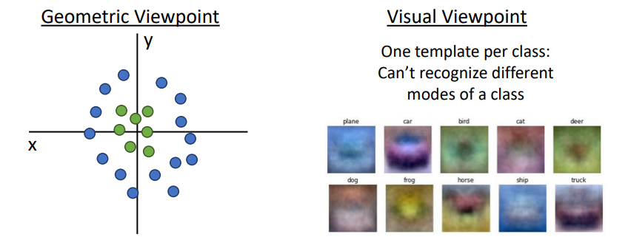Whilst linear classifiers are easy to understand (see Lecture 3), they are limited in their performance. For example, using the geometric viewpoint, a linear classifier is unable to model data that isn’t linearly separable. Or using the visual viewpoint, due to only being able to learn one template per class, a linear classifier is unable to recognize different modes of the same class (e.g. a horse facing either left OR right).

## Feature Transforms

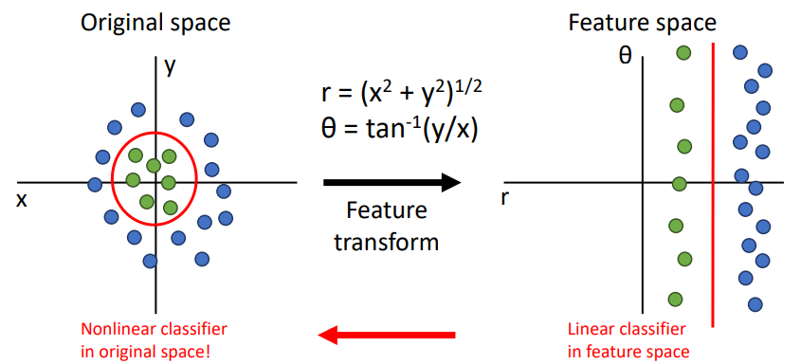One potential solution to these shortcomings is the use of **feature transforms**. We essentially transform our original data into a form that is better suited to our linear classifier, i.e. a form that is linearly separable. As an example, take the data arranged in a circular manner below:

By applying some cleverly chosen mathematical transformation, chosen manually using our intuition, we can convert the above data from cartesian form in the original data space into polar form in “feature space”. The learned linear decision boundary in the feature space can then be transformed back into a *non-linear* decision boundary in the original data space!

### Image Features: Color Histogram

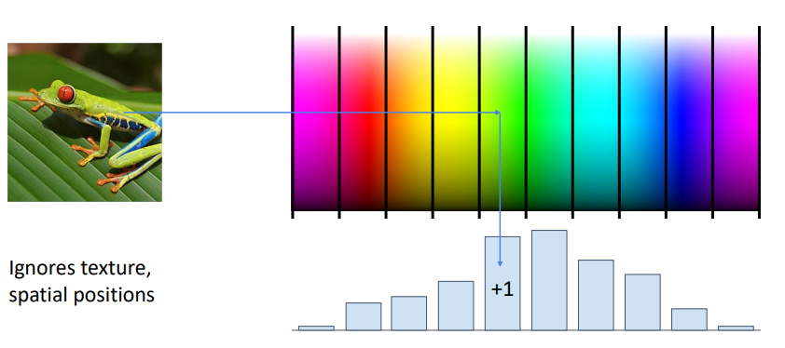One example of a feature transform that we may use in computer vision is the notion of a **colour histogram**. This technique involves discretising the colour space into discrete bins, and then for each pixel in the image, calculating in which bin that pixel is, and then constructing a normalised histogram across the whole image.

This colour histogram representation of the input image throws away any spatial information and only cares about what colours are present in the image, i.e. it is spatially invariant (can recognise a red car anywhere in the image as long as the colours are the same).

### Image Features: Histogram of Oriented Gradients (HoG)

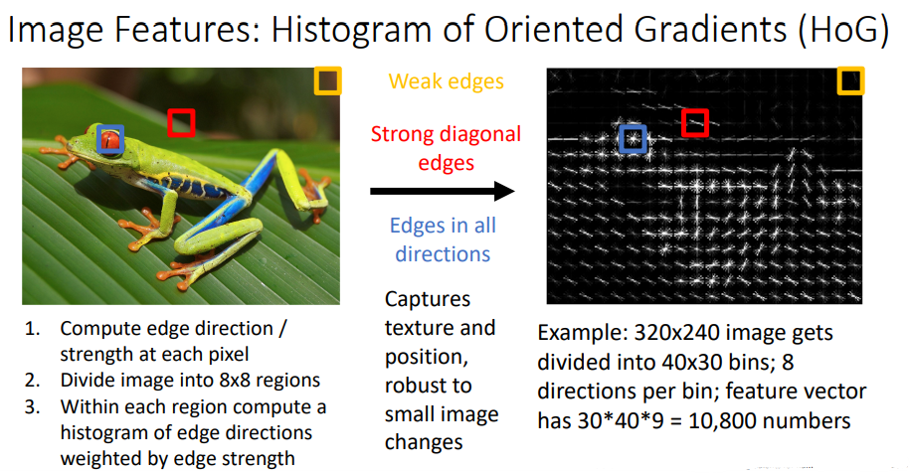HoG does essentially the opposite of the colour histogram; it throws away colour information and encodes the edge directions and strengths at different points in the image.

### Image Features: Bag of Visual Words (Data-Driven!)

Whilst the above two feature transforms require some case-by-case decision making and understanding of the problem, we can use data-driven approaches that are informed by the specific data contained within the training dataset.

One such feature transform is the Bag of Visual Words (BoVW), which follows these steps:

1. **Feature Extraction:** extract feature patches within the image using a feature detector like SIFT, such that each image is represented by a number of patches
2. **Clustering:** group similar patches from the training dataset together using somethinglike K-means clustering, such that each centroid is a “codeword”, i.e. a representation of several similar patches.
3. 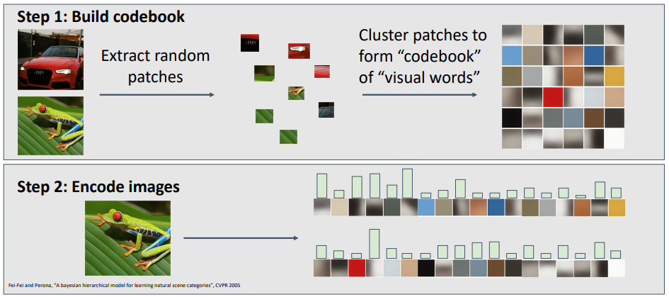**“Codebook” Histogram:** each image can be represented by a “codebook” histogram of how often each “codeword” appears in it.

### Image Features: Continued

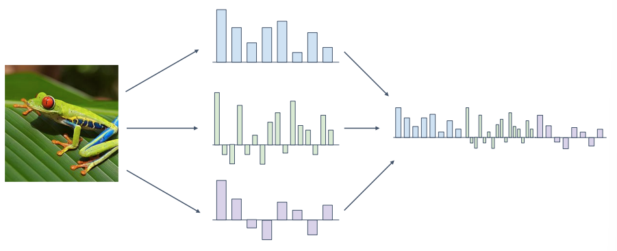You do not have to settle for one feature representation of your images. Instead, you may want to use many feature transforms and concatenate them together into a long high-dimensional feature vector.

For example, the ImageNet 2011 challenge winner combined SIFT features with colour features, and then later Fisher vector features to enhance their dataset before training on a SVM linear classifier with SGD.

## Neural Networks

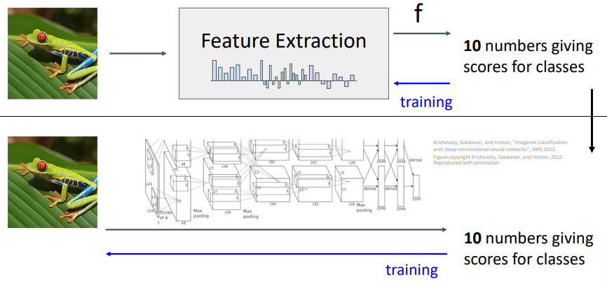Whilst a feature extraction classifier system does most if not all of it’s learning in the classifier portion of the system, *neural networks can be thought of as a combined feature extractor and classifier in one where the feature extraction behaviour is also learned during training*.

A linear classifier has the form:

$$f\left(x\right)=Wx+b$$

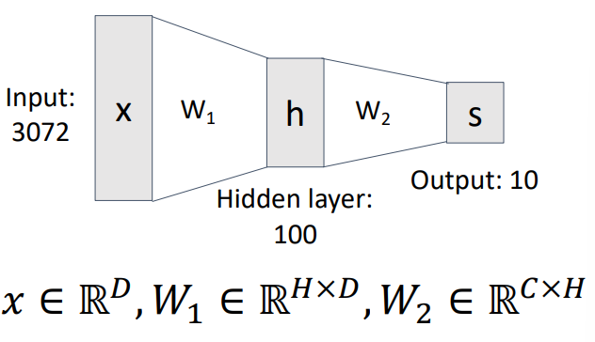We can create a two-layer neural network using the form:

$$f\left(x\right)=W_{2}\max\left(0, W_{1}x+b_{1}\right)+b_{2}$$

Where $max$ is the **activation function**, and the first layer can be thought of as doing feature extraction, whilst the second layer is the linear classifier.

As every neuron in the hidden layer is connected to every neuron in the input and output, this type of neural network is called a **fully-connected** neural network or a **multi-layer perceptron**.

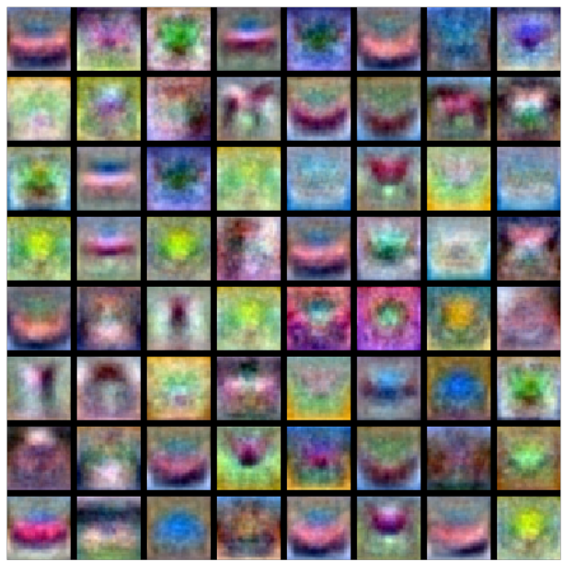Extending the visual viewpoint discussed above, the first layer in a two-layer fully connected neural network can be thought of as a bank of templates, rather than simply one template per image class. Where the templates can look something like:

The second layer then recombines the templates into a classification score. The bank templates are often not visually interpretable (some above look like horses or cars, some look like nonsense), they form more of a “distributed representation”. Notice above that there is a template of a left-facing horse and a right-facing horse, covering multiple modes of a single class!

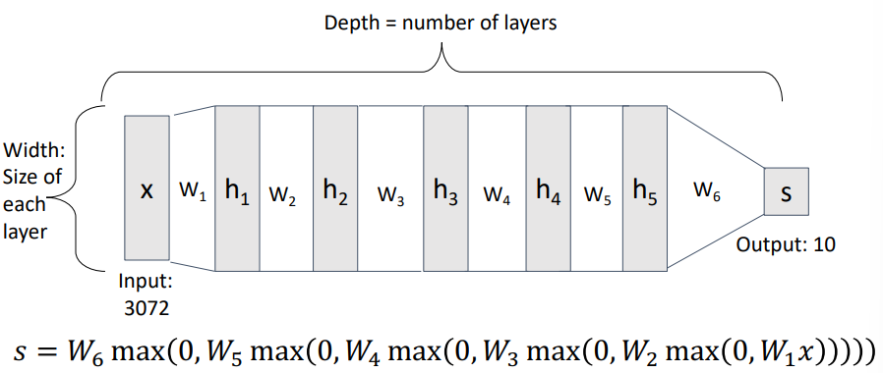The fully connected neural network idea can be extended to deep neural networks with many layers:

### Activation Functions

A fully connected neural network with no activation function between the layers is simple a linear classifier! For example:

$$f\left(x\right)=W_{2}\left(W_{1}x+b_{1}\right)+b_{2}=\left(W_{1}W_{2}\right)x+\left(W_{2}b_{1}+b_{2}\right)$$

Activations functions are required to enable the neural network to model non-linear systems.

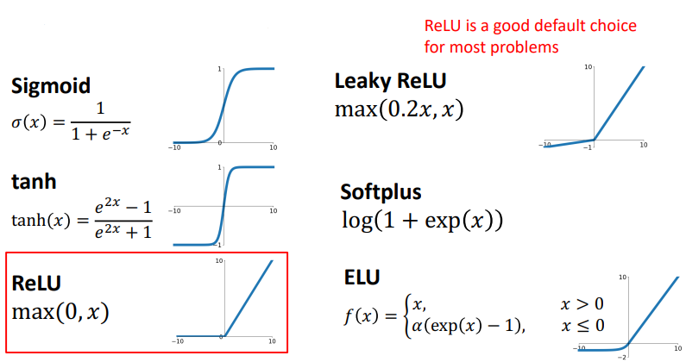Some common activation functions are given below:

ReLU is often a good default choice for most problems.

#### Activation Functions: Space Warping

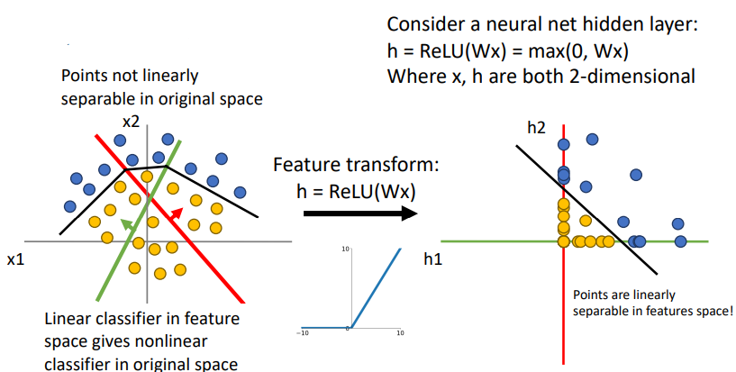Consider transforming a bunch of classified points (blue and orange) from x1, x2 coordinate axes to h1, h2 coordinate axes. If the points are not linearly separable in the original space then if the transformation is linear, they will not be linearly separable in the new space. However, if the transformation is a ReLU transform, any points with a negative x1 or x2 value will become 0 in h1 or h2 respectively. This is illustrated below:

### Universal Approximation Theory

“A neural network with one hidden layer can approximate any function with arbitrary precision.” This tells us that neural networks can represent any function, however it DOES NOT tell us whether we can actually learn any function with SGD, or how much data is actually required to learn a function (recall that kNN is technically a universal approximator, given ridiculously large quantities of data).

### Convex Functions

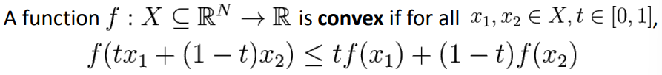A function is convex in the region $x_{1}$ to $x_{2}$ if it satisfies the following:

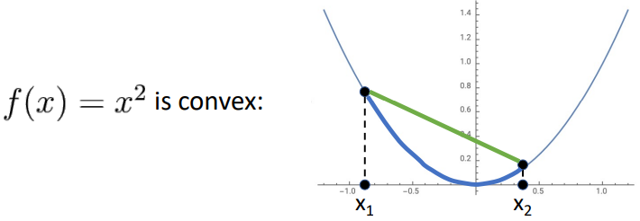**I.e. the function is convex in the region $x_{1}$ to $x_{2}$ if all of its values in that region sit below the secant joining the two points (a convex function is a multidimensional bowl).**

Generally speaking, convex functions are easy to optimise; we can derive theoretical guarantees about converging to global minimum.

Linear classifiers optimise a convex function; therefore, they can be shown to be guaranteed to converge.

Neural networks on the other hand need nonconvex optimisation, so there are few or no guarantees about their convergence. Empirically however, they seem to work anyway. The theory of the mathematics behind their optimisation is still an active area of research.

# Lecture 6 – Back Propagation

The optimisation algorithms described above rely on understanding the gradients of the model’s parameters with respect to the loss function.

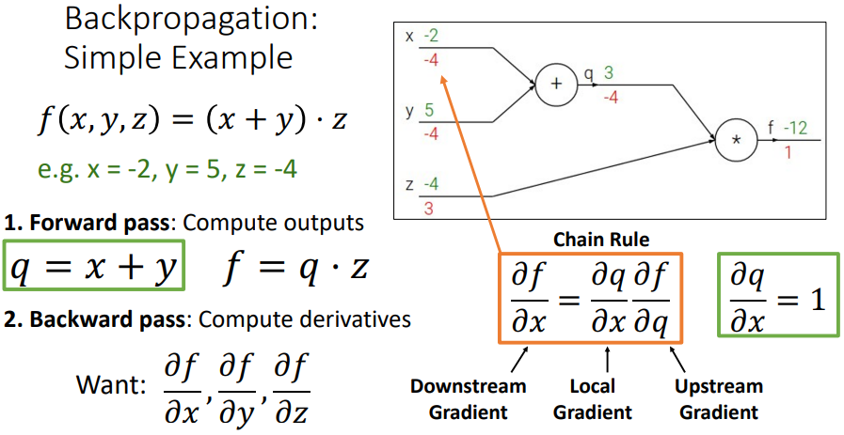Back propagation provides a method for computing gradients via recursive applications of the chain rule.

## Derive gradients on paper

Whilst writing down the full form of the loss function in terms of the model parameters and then calculating their gradients is technically possible, it is infeasible in most cases due to:

* Involving lots of matrix calculus
* Being non-modular, i.e. switching from SVM to softmax loss would require rederiving from scratch
* Too complex and time intensive for large, complicated models

## Computational Graphs

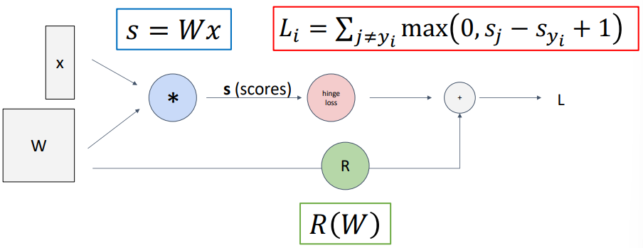Computational graphs are directed graphs that represent the computations that are occurring within the model:

Below is a very simple example of how to use a computational graph to calculate the gradients of a simple function. The steps are:

1. Complete the **forward pass** to find the outputs at each step along the model
2. Complete the **backward pass**, calculating the derivatives of the output $f$ with respect to each input $x$, $y$, $z$, using the chain rule.

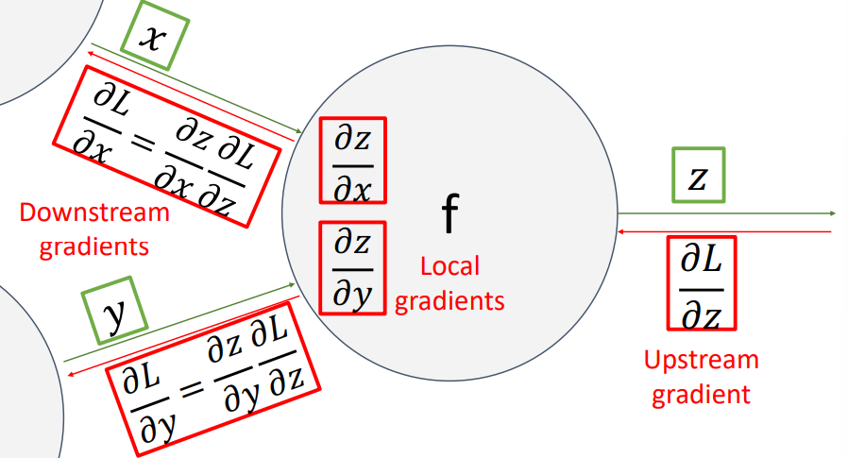Referencing some specific layer in the model (i.e. node in the graph) as “local”, the gradient of the model’s output with respect to the layer’s output is called the **upstream gradient**. The gradients of the layer’s output with respect to each of the layer’s inputs are the **local gradients**, and the gradients of the model’s output with respect to each of the layer’s inputs are the **downstream gradients**.

### Patterns in Gradient Flow

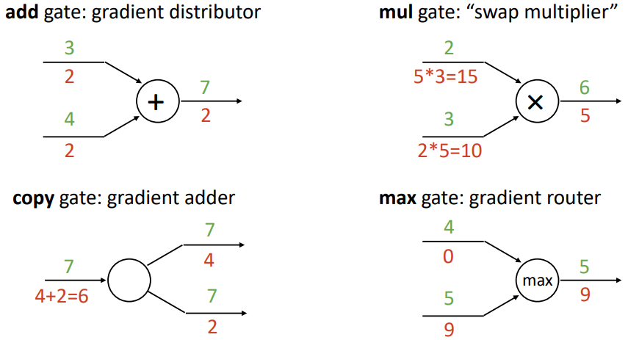Gradients flow back through the network and are affected by different operations (“gates”) in the following ways:

### Backprop Implementation: “Flat” gradient code

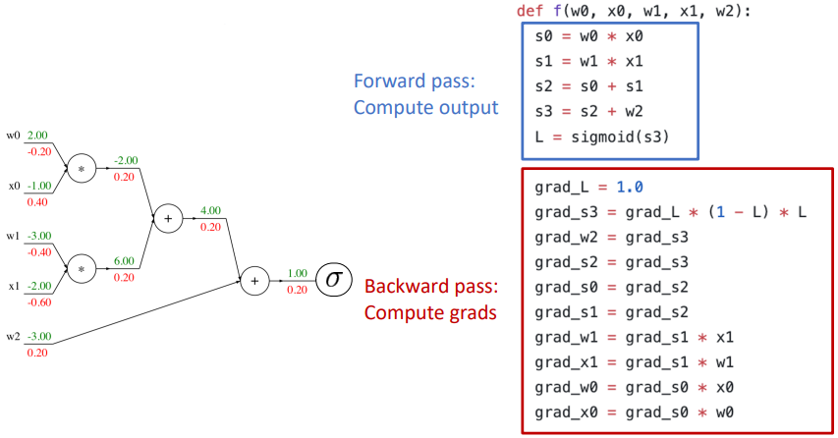The above general rules can be used to write “flat” gradient code, where the forward pass is written first from start to finish, and then the backward pass is written immediately after from finish to start. The gradient code is essentially a reversed version of the forward pass, where each operator in the forward pass has its corresponding gradient effect. E.g.

### Backprop Implementation: Modular API

“Flat” gradient code is not modular; it must be rewritten manually if the structure of the network changes. Instead, we can construct a modular API to conduct backpropagation, with the following steps:

1. 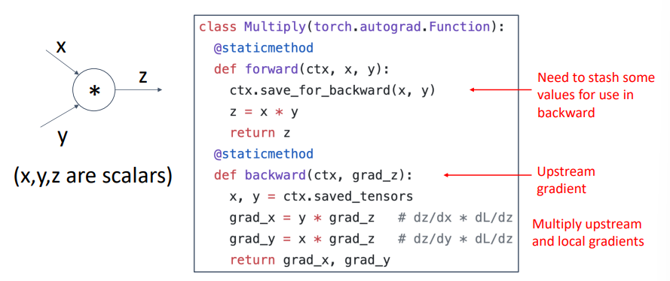Create a node object for every input gate / node (i.e. each individual “add”, “multiply”, “max” instance, etc.) and assign them to the computational graph
2. Sort the nodes in the computational graph topologically (i.e. in the order that the inputs travel through the graph)
3. Perform the forward pass by traversing through the sorted nodes, calling each of their .forward() methods and storing any information that will be required for the backward pass
4. 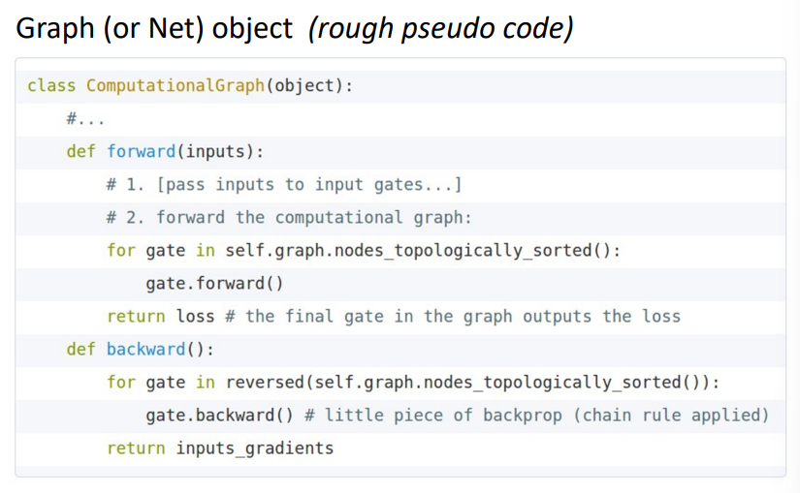Perform the backward pass by traversing through the reverse of the sorted nodes, calling each of their .backward() methods, retrieving the previously stored information from the forward pass

## Vector and Tensor Backpropagation

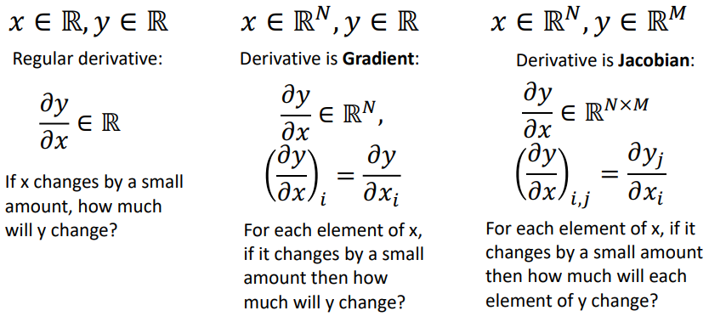So far, we have only considered backpropagation with scalar values. To backprop with vectors and tensors, we will need to recall the definition for the gradient and for the Jacobian:

### Vector Backpropagation

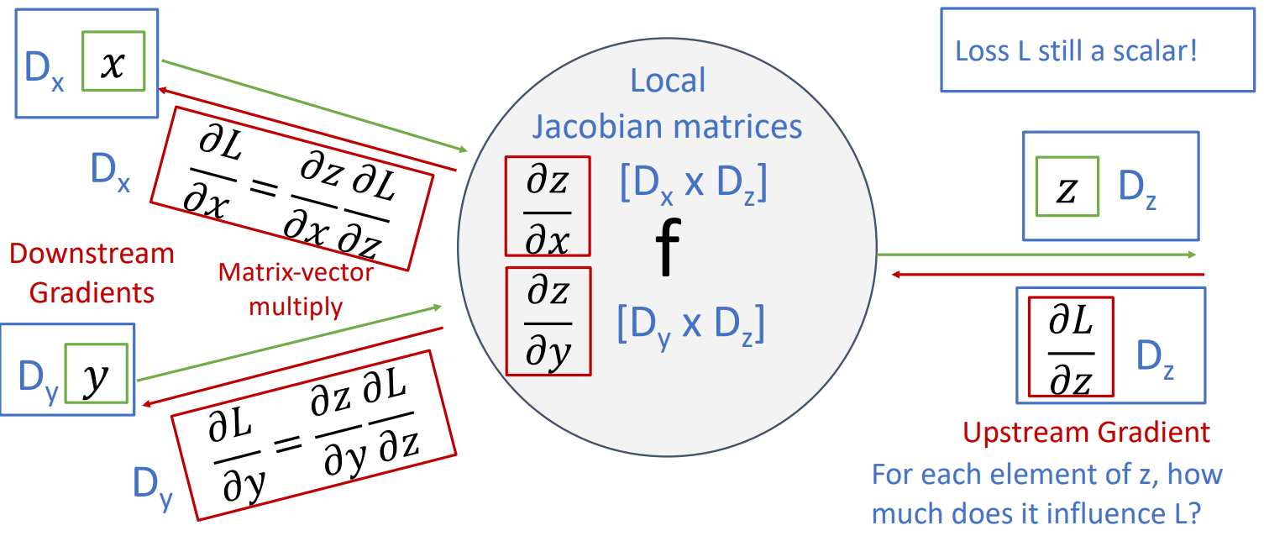Loss $L$ is a scalar, regardless of the form of the model inputs. If the inputs $x$ and $y$ are vectors of dimension $D_{x}$ and $D_{y}$ respectively, and the output $z$ is a vector of dimension $D_{z}$:

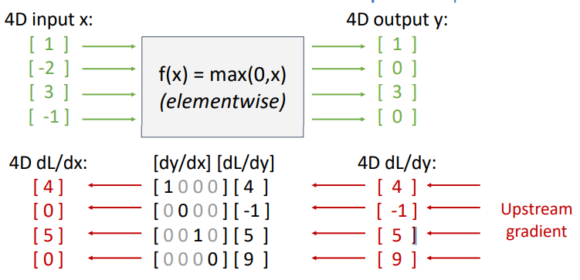Explicitly constructing the Jacobian matrices can quickly become expensive as the input dimensions grow. Luckily, it is often possible to never explicitly form the Jacobian and instead perform **implicit multiplication** where the Jacobian would typically be used, i.e. the local gradient is never formed. For example, the element-wise ReLU function $f\left(x\right)=\max\left(0, x\right)$ has the effect of zeroing the gradient of any negative input and simply passing through the gradient of any positive input. Constructing the Jacobian for this function gives a sparse diagonal matrix; all off-diagonal values are zero.

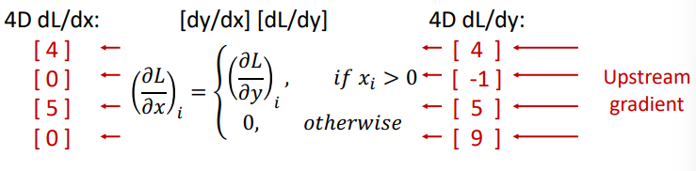Instead of using the Jacobian explicitly, we can perform an equivalent but much more efficient implicit operation:

### Tensor Backpropagation

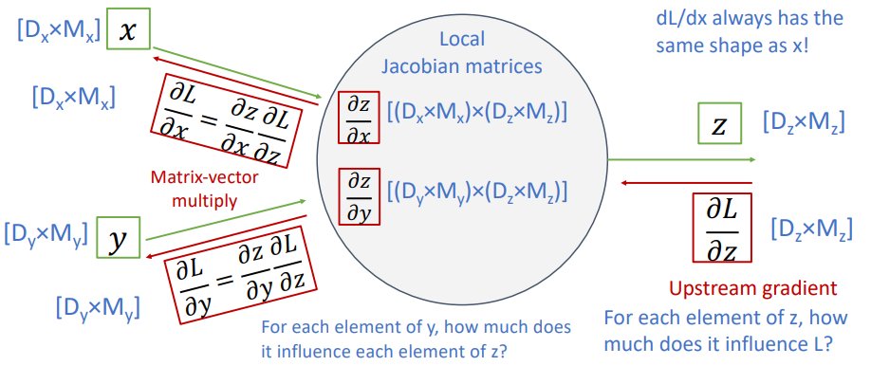Again, loss $L$ is a scalar. Constructing a similar diagram to that given for vector backpropagation above, gives:

Forming the Jacobians in this case is infeasible (for a neural network with $N=64$, $D=M=4096$, each Jacobian requires 256Gb of memory), we must work with them implicitly.

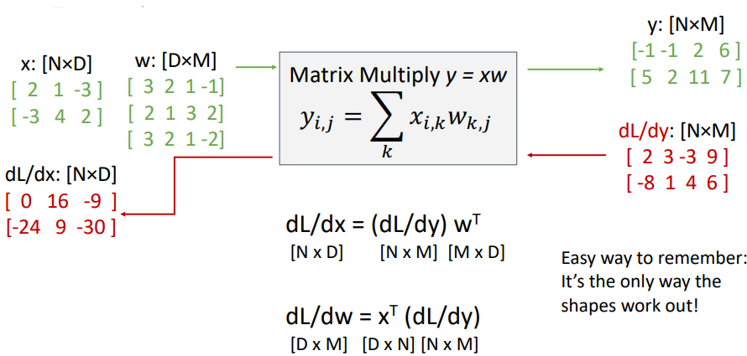Matrix multiplication in backpropagation is done implicitly – to calculate the downstream gradient directly from the upstream gradient – in the following manner (see Lecture 6 slides for derivation technique):

### Automatic Differentiation

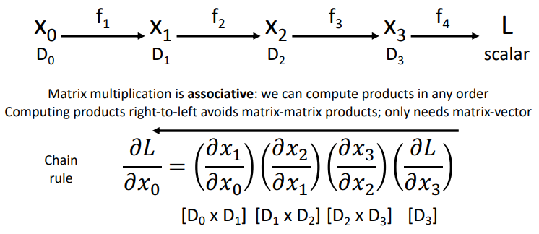Say we have some vector input $x_{0}$ and any series of functions $f$ that give a scalar output $L$, **reverse-mode automatic differentiation** (aka backpropagation) can be performed as:

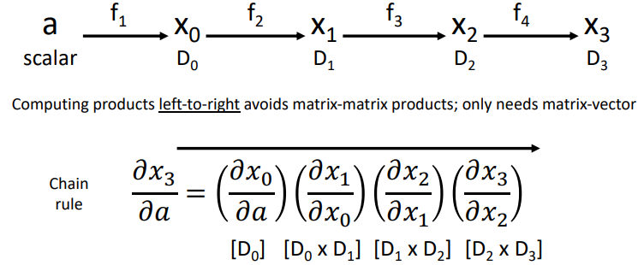If instead we have some scalar input $a$ and any series of functions $f$ that give a vector output $x_{3}$, **forward-mode automatic differentiation** can be performed as:

### Higher-order Derivatives

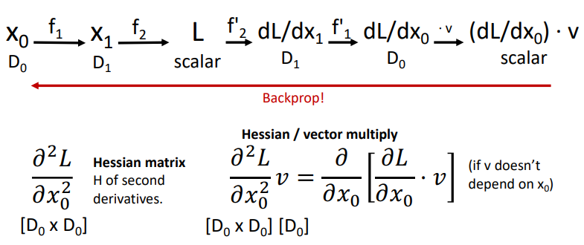Backpropagation also provides a convenient method for computing higher-order derivatives. For a given model, simply define a forward pass through some new model in a clever manner such that performing backpropagation on this new model will yield the higher-order derivative of interest. For example, calculating a Hessian / vector multiply:

# Lecture 7 – Convolutional Networks

Both the linear classifier and fully-connected layer neural network that we have looked at so far do not respect the spatial structure of the input images. They require stretching the pixels into a single vector, effectively destroying the spatial information.

## Convolution Layer

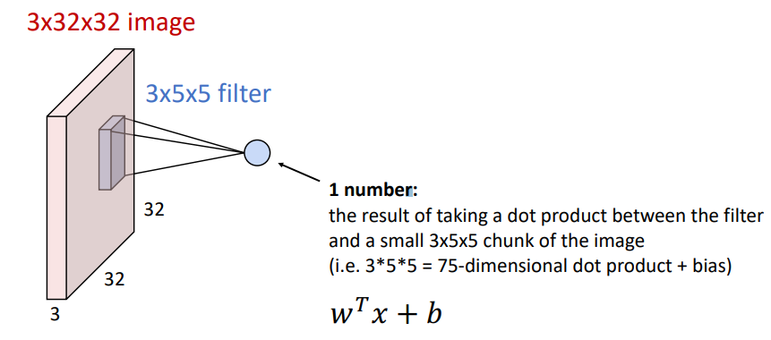Convolution layers preserve the spatial structure of input images by acting on the image in its original dimensions. Whilst each output of a fully-connected layer is determined by every pixel in the input image (i.e. “fully-connected”), a convolution layer slides a filter/kernel over the image spatially, computing a local dot product such that the output at that location is only dependent on the pixels covered by the filter. For example, a CIFAR10 3x32x32 image and a 3x5x5 convolution filter:

Sliding the filter over the entire image produces an “activation map”. This can be repeated for $n$ different filters to produce a collection of activation maps. There are two handy ways to think of this collection of activation maps:

1. As $n$ individual activation maps, where each map corresponds to the degree to which the entire input image responded to that map’s filter.
2. As a grid of $n$ dimensional vectors, where each vector encodes information from all $n$ filters at that grid location.

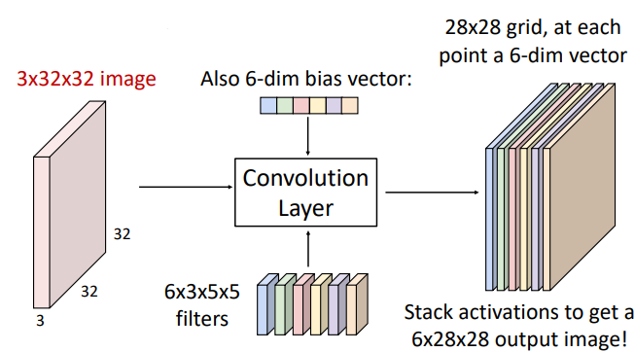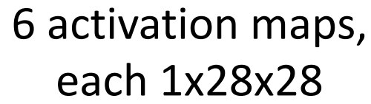

OR

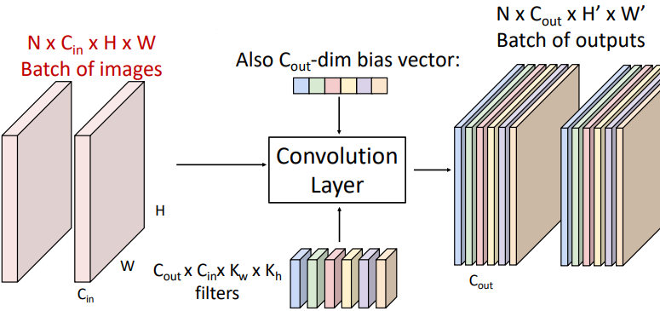The general form for a convolution layer is given below. Noting that for each channel in the output, there is a single scalar **bias** value that is added to each element in that channel’s output map.

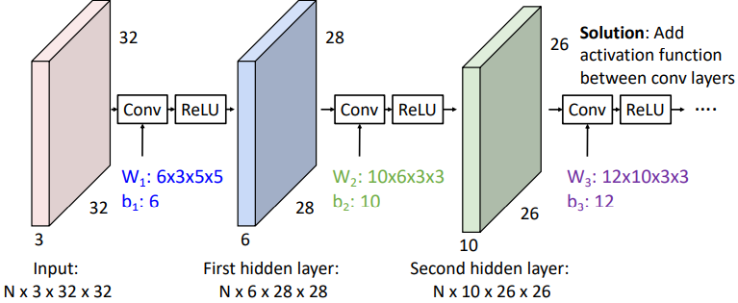Similar to how stacking multiple fully connected layers together without activation functions is equivalent to one fully connected layer, stacking convolutional layers must be done with activation functions between each layer.

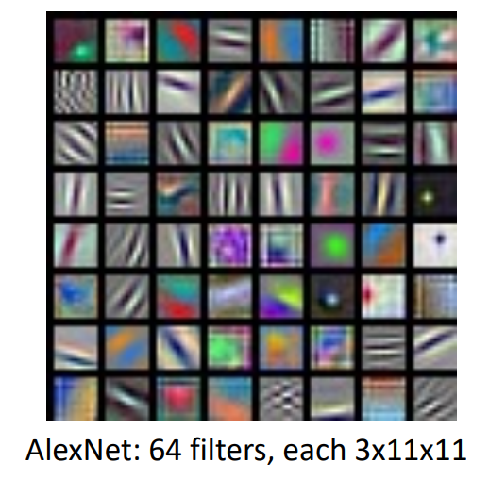Whilst fully connected layer neural networks learn a bank of whole-image templates, first-layer convolution filters learn local image templates (i.e. filters to extract things like orientated edges, opposing colours, etc.). Below are the 64 learned filters in the first layer of AlexNet, each 3x11x11:

### Receptive Fields

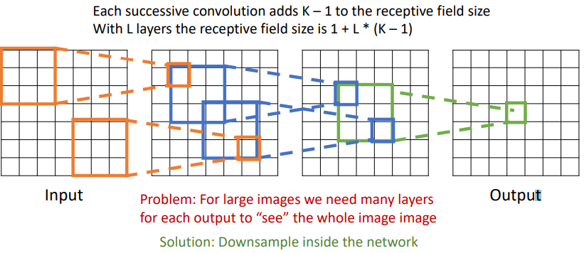For a convolution layer with kernel size K, each element in the output depends on a KxK receptive field in the layer’s input. This can be repeated back through multiple layers:

The above mentioned problem of requiring many layers to allow the receptive field of the model’s output to depend on the whole input image (especially for high resolution inputs) can be solved by downsampling using a **stride**. The stride of the convolution is how many places the kernel is moved along the input before evaluating each output.

### Convolution Output Size

For an input of dimension $\left(N, C_{in},H_{in},W_{in}\right)$, $C_{out}$ number of kernels of size $K$, padding $P$, and stride $S$, the output will have dimension $\left(N,C_{out},H_{out},W_{out}\right)$, where:

$$H_{out}=\frac{H_{in}-K+2P}{S}+1, W_{out}=\frac{W_{in}-K+2P}{S}+1$$

### 1x1 Convolution

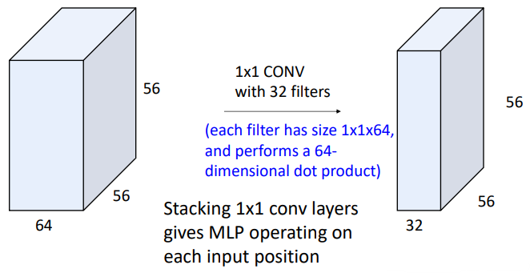Applying a convolution of $C_{out}$ number of kernels of size 1x1 on an image effectively performs a fully connected layer (MLP) operation on each input position. This is sometimes referred to as a “Network in Network”.

### 1D and 3D convolution

2D convolution is the most common in computer vision applications, but 1D and higher dimension convolution operations exist.

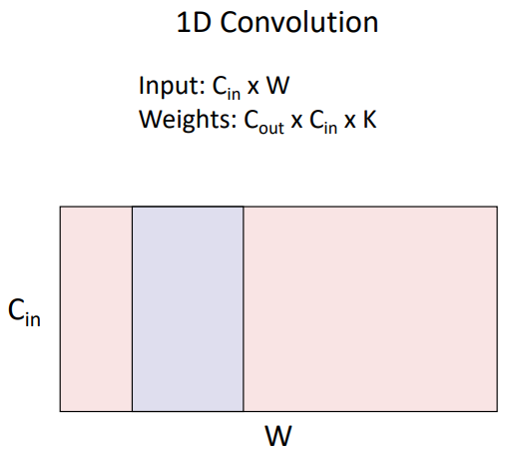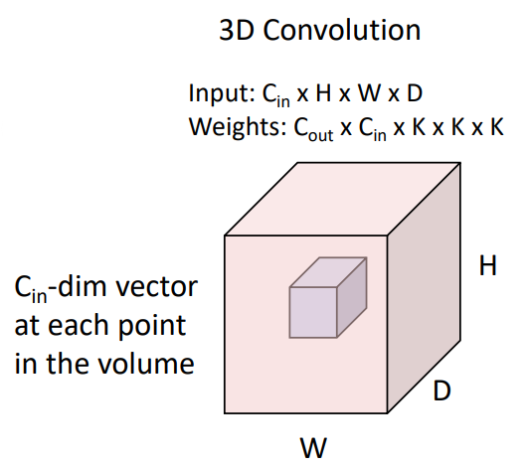

### Convolution Layer Summary

## Pooling Layers

Another component of convolutional networks is the **pooling layer**. Pooling layers serve as another way to downsample an input. They achieve this by sliding a kernel of size $K$ over the input image with stride $S$ and performing a pooling function on the inputs within the kernel. This is typically either **max pooling**, where the maximum value in the kernel becomes the output, or **average pooling**, where the average value in the kernel becomes the output. Max pooling is 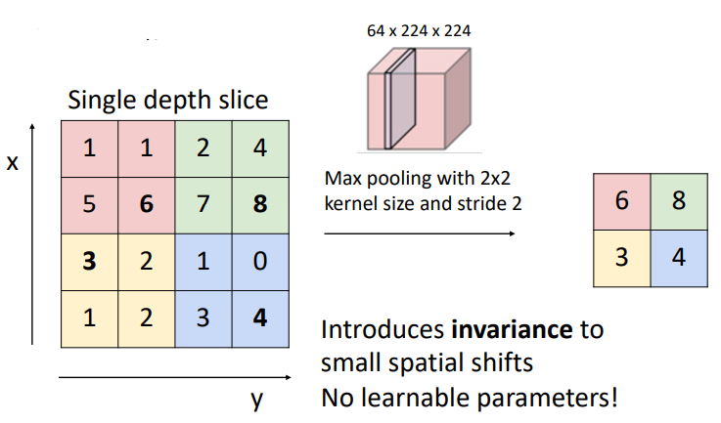demonstrated below:

Max pooling introduces invariance to small spatial shifts (e.g. as long as the maximum values are still within the same colours above, the output is the same). Pooling in general acts to reduce overall model complexity, shortens training time, and improves generalisation.

### Pooling Summary

## Example Conv. Network – LeNet-5

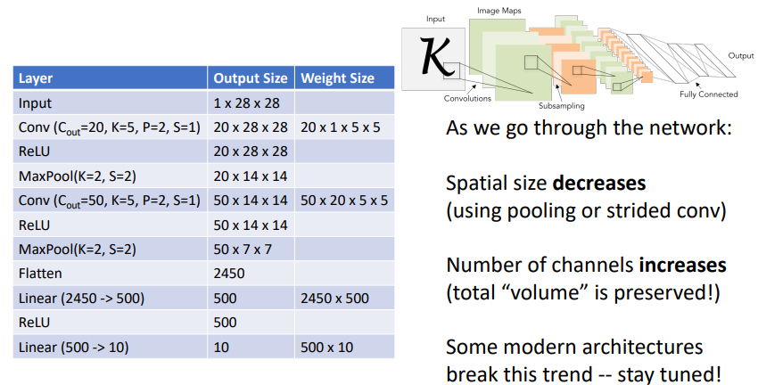Convolutional networks almost always also contain some fully connected layers. The output from the previous convolution layer is first flattened (for the same reason images need to be) before being processed by the fully connected layer.

## Normalisation

The final typical component of a basic convolutional network is **normalisation**. Normalisation solves the problem of “internal covariate shift”, where the distribution of the inputs to a given layer changes during training as the parameters of the previous layers change. As the training progresses, the layers keep receiving different input distributions, which makes it harder for the model to learn efficiently. Each layer has to constantly adjust to these shifting distributions, slowing down training.

By normalizing, the layer inputs maintain a stable distribution throughout training, which reduces the internal covariate shift. This means each layer gets more consistent and predictable inputs, making it easier for the network to learn. The model parameters are less likely to experience large shifts in scale, and the gradients during backpropagation don’t explode or vanish, leading to faster convergence.

We can normalise a batch of activations like by subtracting the mean and dividing by the standard deviation:

$$\hat{x}=\frac{x-E\left[x\right]}{\sqrt{Var\left[x\right]}}$$

Note: This is a differentiable function, so we can backpropagate through it!

### Batch Normalisation – Fully Connected Networks

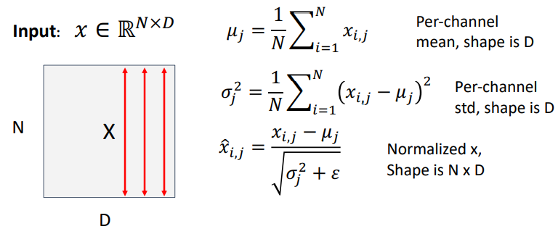If we have a batch of $N$ inputs, each of size $D$, for each channel $j$ along the input dimension $D$ we will calculate an empirical mean $μ_{j}$ along the batch dimension $N$. This mean $μ_{j}$ will then have size $D$ (i.e. the average of every input location across the $N$ batches). We can then do the same thing to calculate the per-channel standard deviation $σ_{j}$. Every element in the $N×D$ input can then be normalised to **zero mean**, **unit variance** (see below for why this isn’t typically done) by subtracting the mean and dividing by the standard deviation. This is illustrated below:

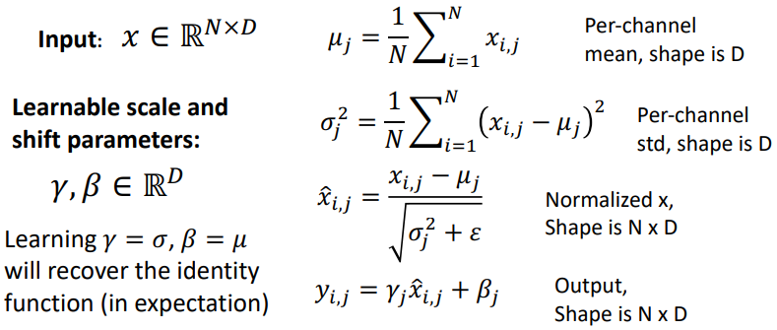Forcing the input to be normalised to zero mean, unit variance is probably too hard of a constraint to place on the model. Instead, we can learn some scale and shift parameters $γ, β$ of size $D$ to allow the model to decide what means and variances it wants to see for each channel in the input. This is shown below:

#### Batch Dependence and Use at Test-time

Whilst the previous operations we have explored (fully connected layers, convolutions, pooling, etc.) operate independently on each input in the batch, batch normalisation obviously depends on what other inputs are present in the batch. **This is a very bad property** at test-time, we do not want the performance of the model to be dependent on what other inputs are also being evaluated at the same time. Therefore, batch normalisation **acts differently during training than at test-time**.

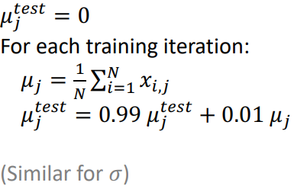During training we continue to calculate the mean and standard deviation across the batch and use them to normalise, however we also keep track of a running exponential average of the mean and standard deviation which will then be constants $μ_{j}^{test}, σ_{j}^{test}$ to be used at test time. That is:

This then means that the result for each input at test-time is again independent of the other inputs in the batch. Another benefit of this approach is that because $μ_{j}^{test}, σ_{j}^{test}$ are constants, batch normalisation becomes a linear operation at test-time. And as we know that a linear operator (fully connected or convolution layer) followed by another linear operator is equivalent to a single linear operator, we can fuse a batch normalisation layer with the previous fully connected or convolution layer at test-time, so that **batch normalisation has zero computational overhead at test-time**.

### Batch Normalisation – Convolutional Networks

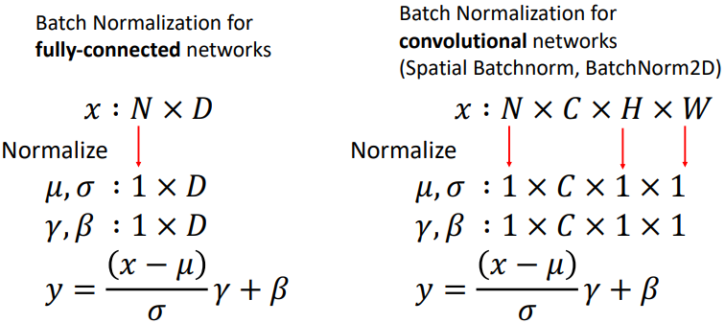Whilst for fully connected networks we compute the mean and standard deviation along the batch dimension, for convolutional networks we compute them along the batch dimension, and the image height and width dimensions. This leaves only the channel dimension, so the mean and standard deviation have size $C$.

### Batch Normalisation – Uses and Summary

Batch normalisation layers are usually inserted immediately after fully connected or convolutional layers, before the nonlinear activation function.

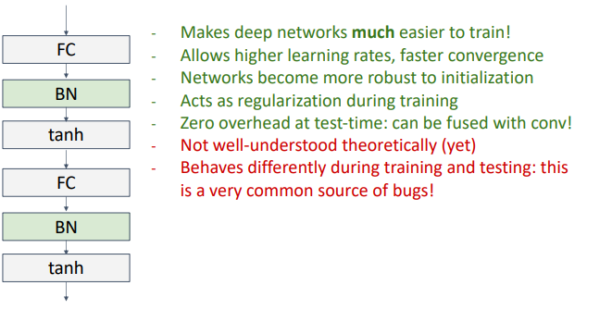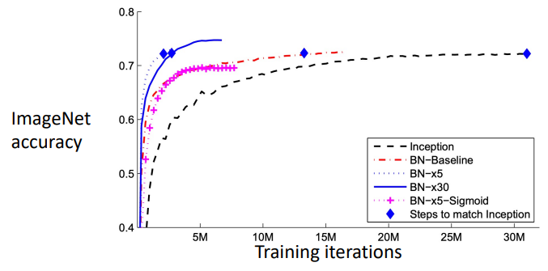

### Layer Normalisation + Instance and Group

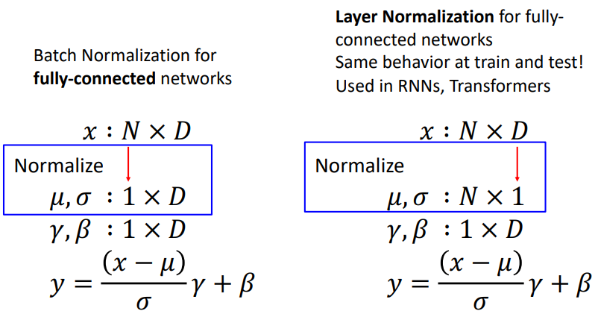Layer normalisation is the same as batch normalisation except instead of calculating the mean and standard deviation for each channel in the input along the length of the batch, we calculate the mean and standard deviation for each input in the batch along the length of the input. For fully connected networks, this looks like:

Now, because this does not rely on any information from the other inputs in the batch, layer normalisation gives the same behaviour at training as at test-time. Layer normalisation is commonly used in recurrent neural networks (RNNs) and transformer networks.

#### Instance Normalisation

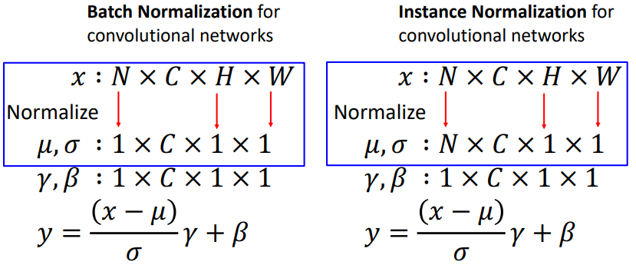A kind of equivalent operator of layer normalisation for fully connected networks but applied to image inputs (i.e. convolution layer outputs) is instance normalisation, where the mean and standard deviation is calculated along only the height and width dimensions. Again, this does not rely on information from other inputs in the batch, so instance normalisation gives the same behaviour at training as at test-time.

#### Group Normalisation

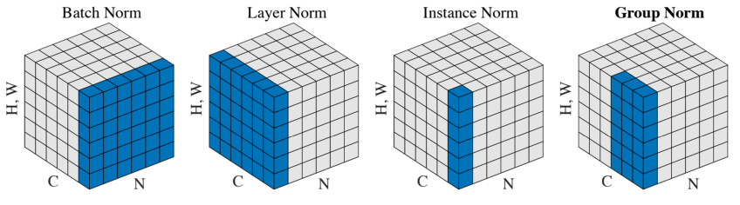Group normalisation has also been proposed and has been shown to work quiet well for object detection. The idea is that you split the channel dimension into some number of groups, and you then normalise over different subsets of the channel dimension. The below image compares the different types of normalisations that we’ve discussed.

# Lecture 8 – CNN Architectures I